Ravishankar A - Project – Weekend 11

**Objective:**

Implementing a microservice using the Python Flask framework on an Ubuntu virtual

machine to serve a machine learning prediction model.

To create a Docker image containing everything needed to run the application: the

application code, libraries, tools, dependencies, and other files and to use the image to run the application in containers.

**Steps to be performed:**

1. Host a Ubuntu Virtual Machine using Oracle VM Virtual Box. (5 marks)

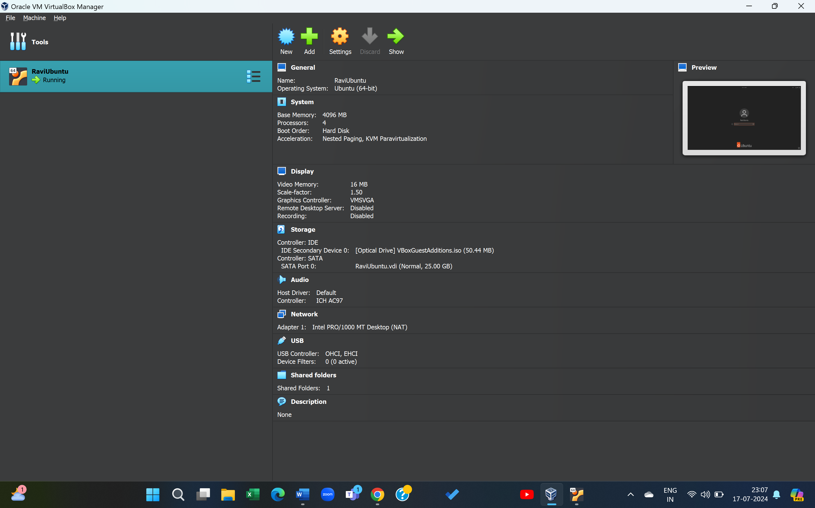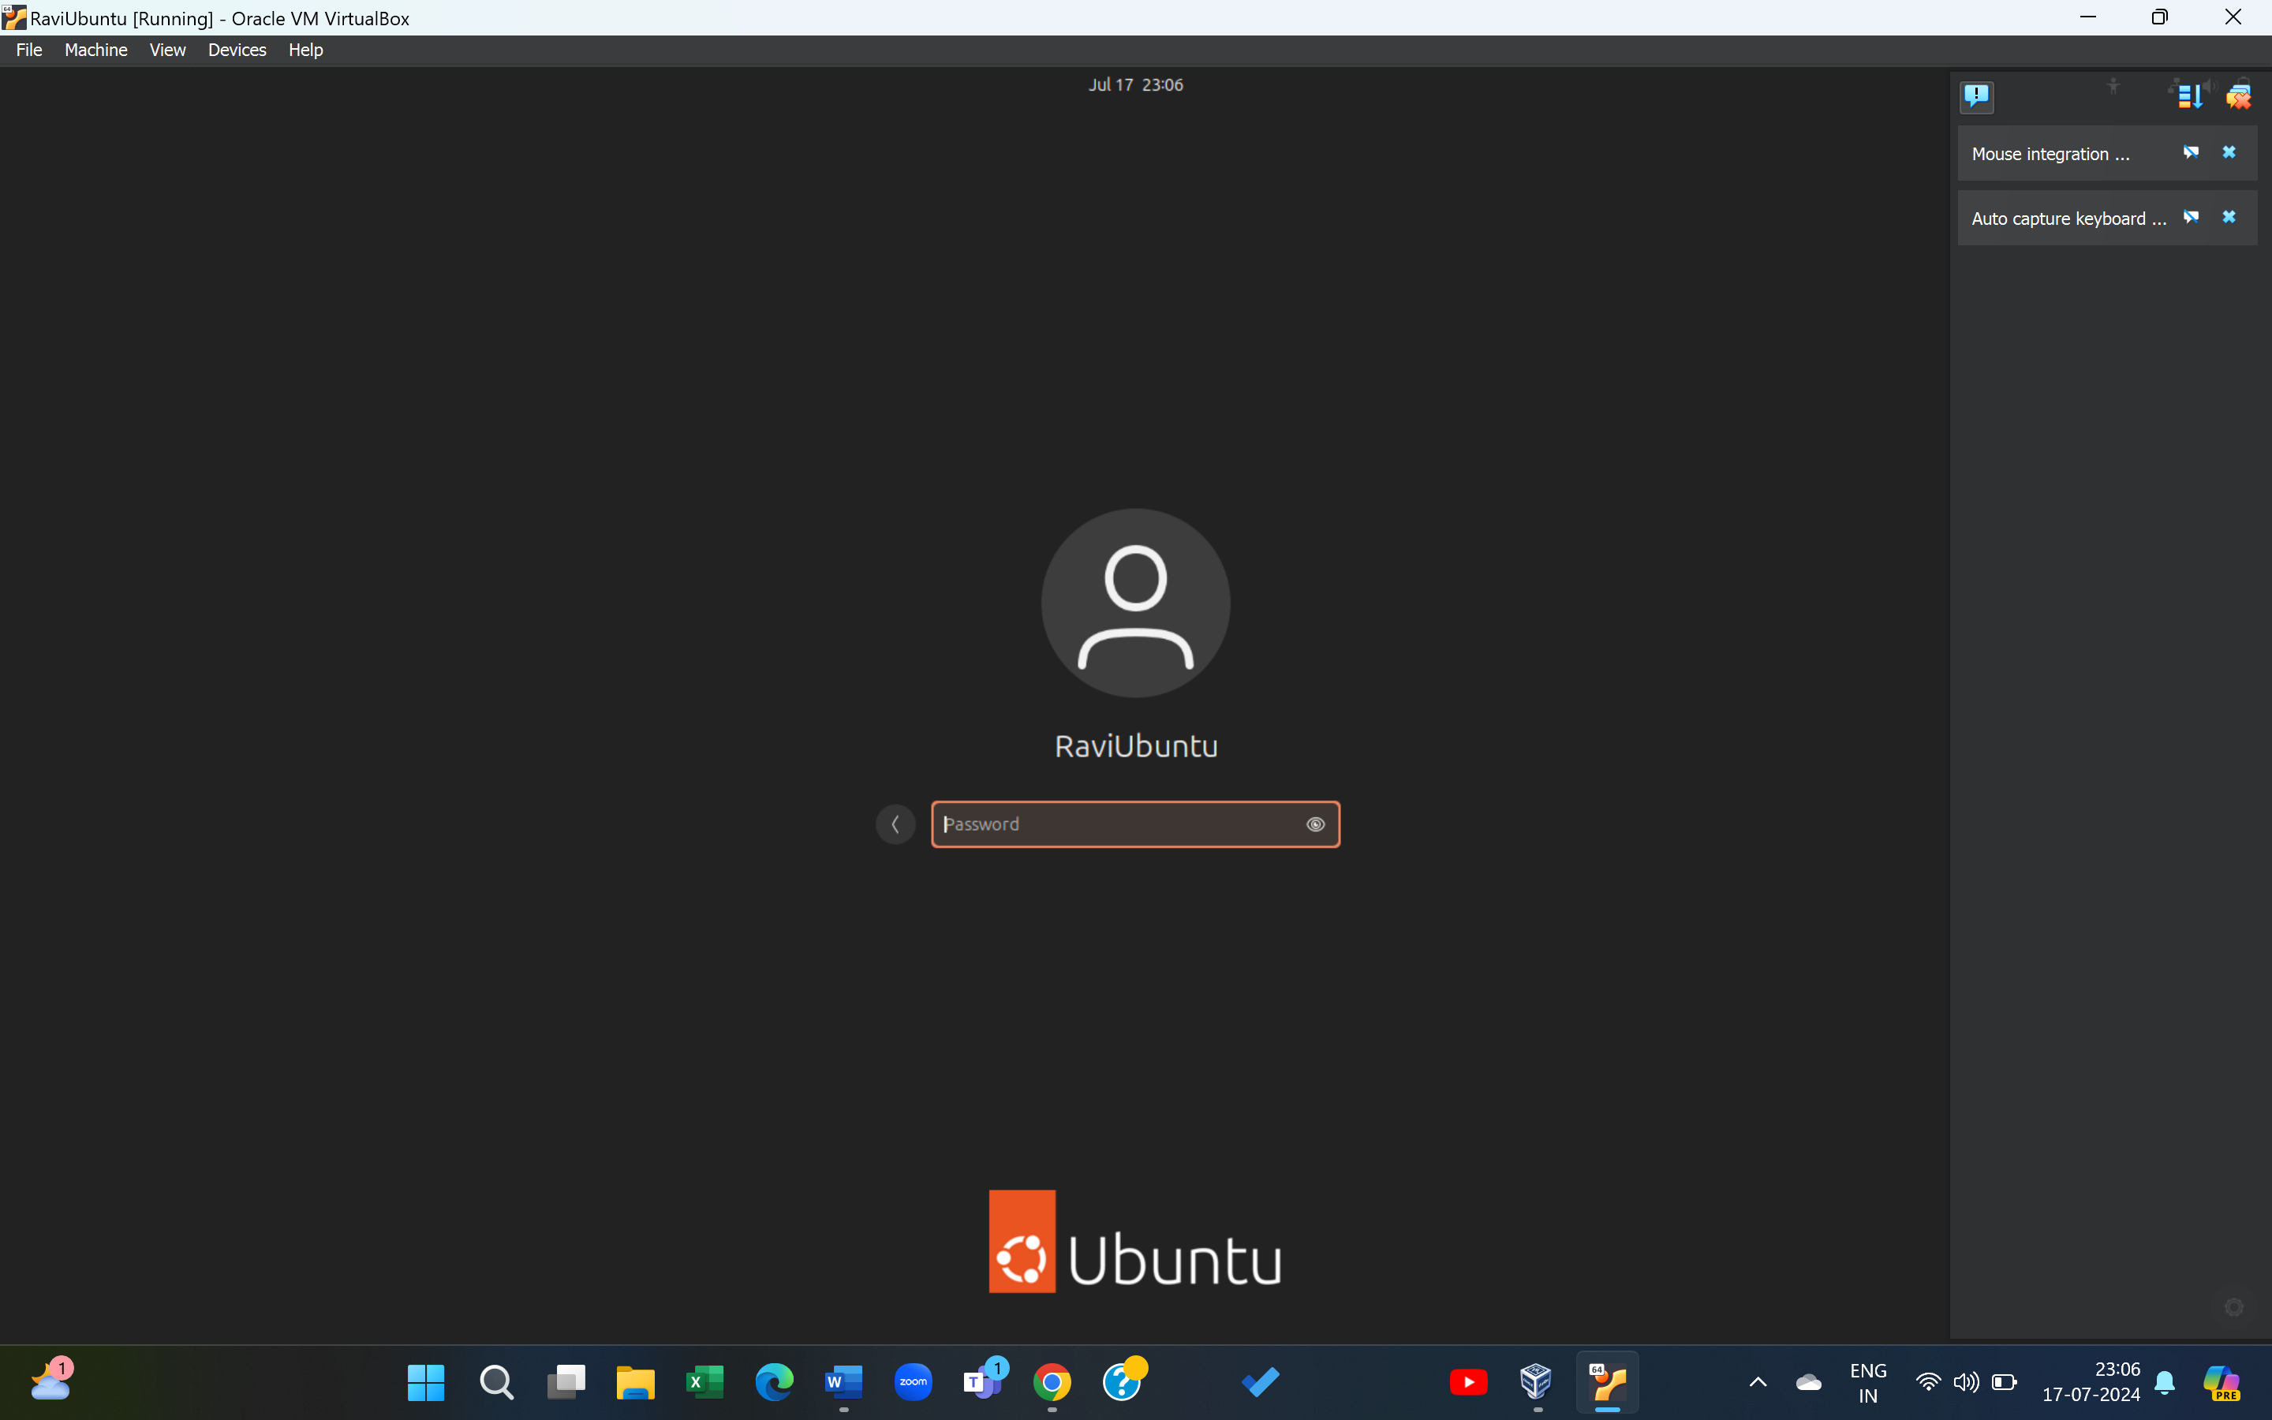

2. Set up Visual Studio code on Ubuntu VM. (5 marks)

3. Set up Python. (5 marks) ***Python 3.10.14 set up***

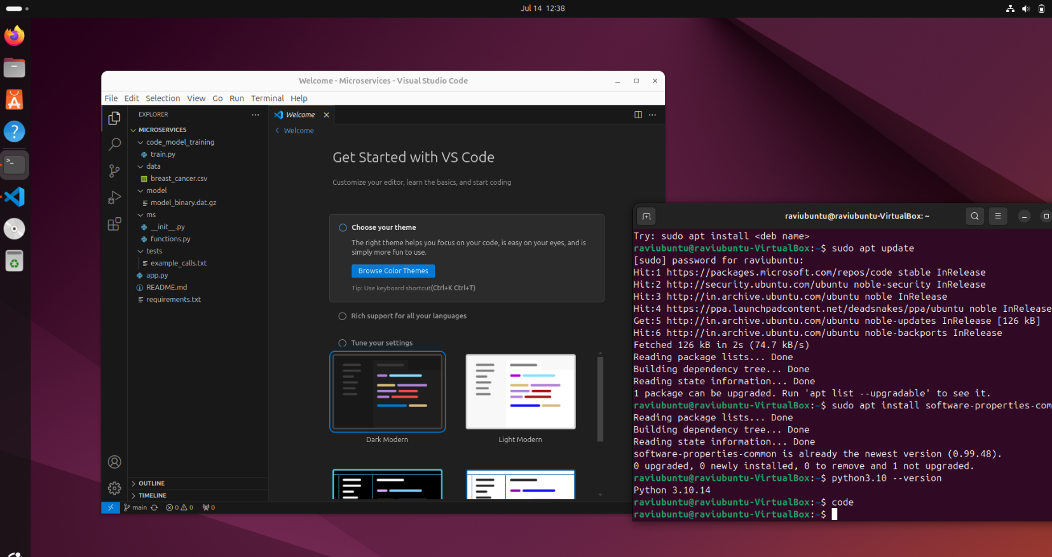

4. Clone this Github repository https://github.com/Vikas098766/Microservices.git (1 mark)

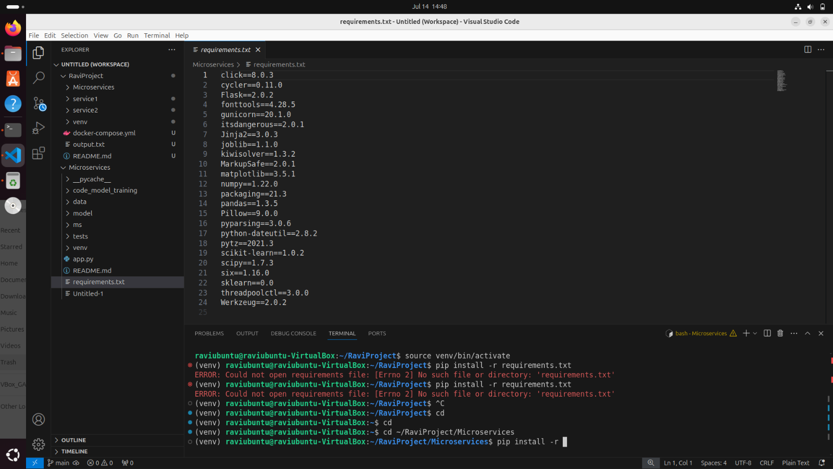

5. Create a Virtual Environment. (1 mark)

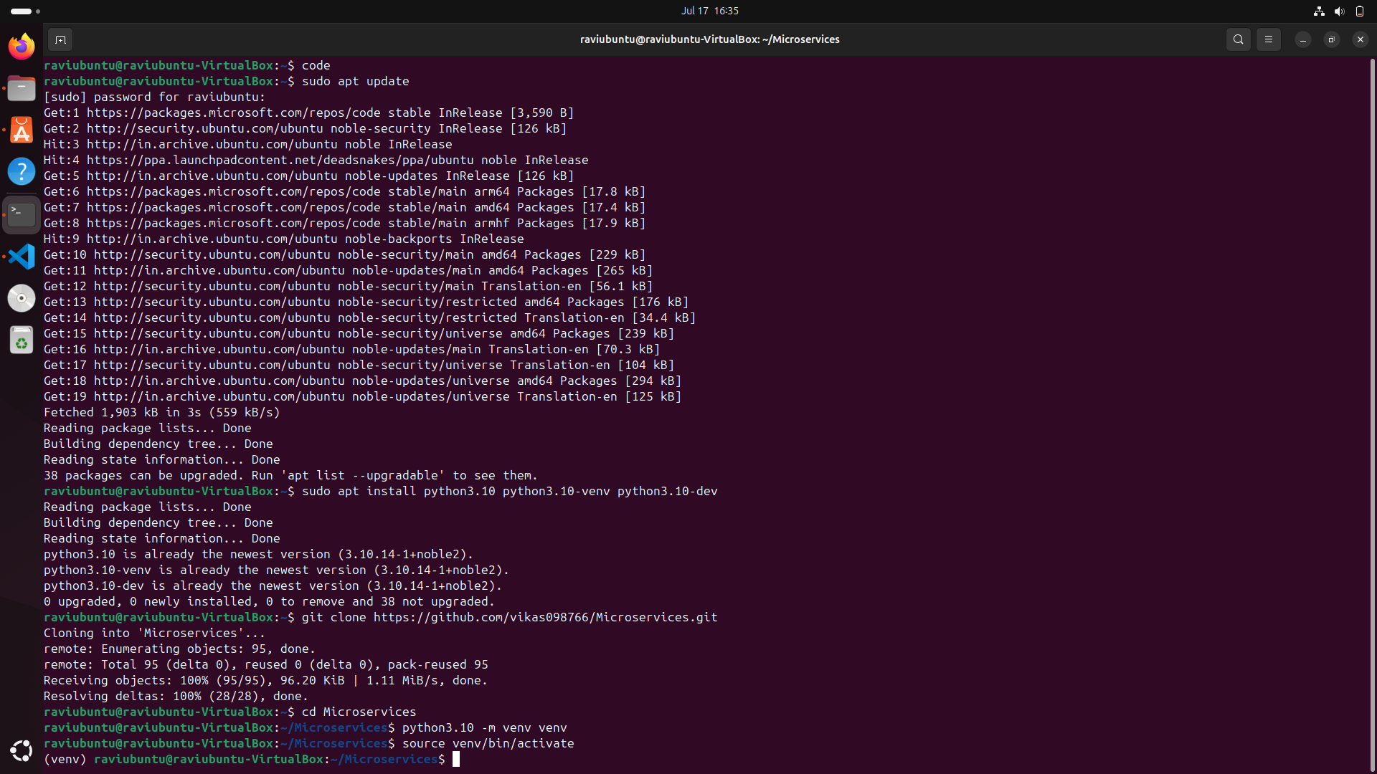

6. Install the dependencies from requirements.txt file. ( 1 mark)

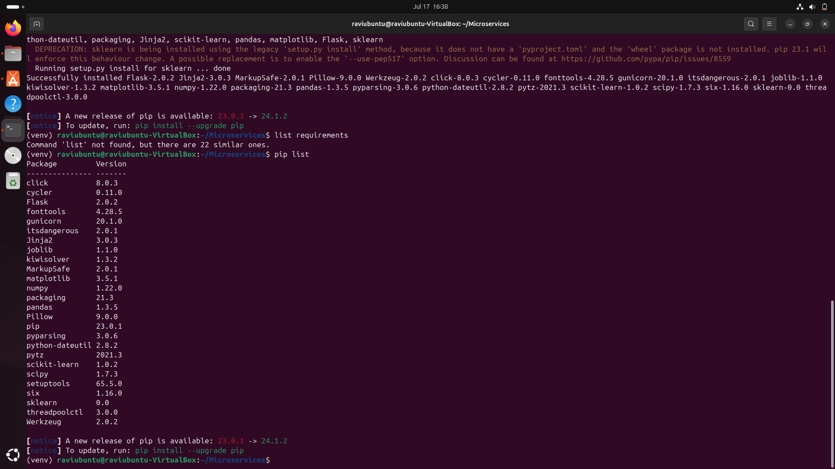

7. Train and save the model. (2 marks)

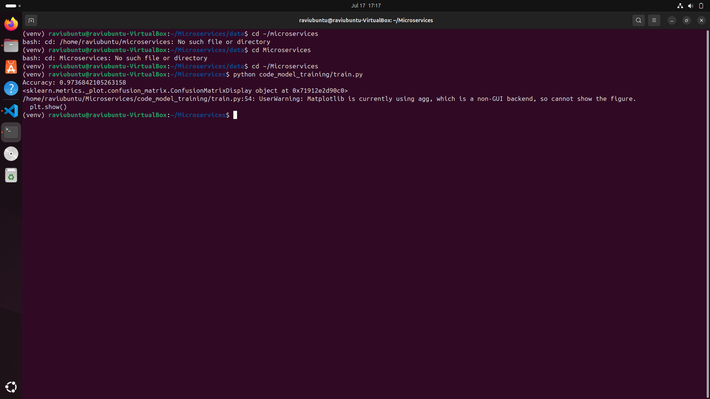

8. Test the Flask web application. (5 marks) (used Docker to set it up)

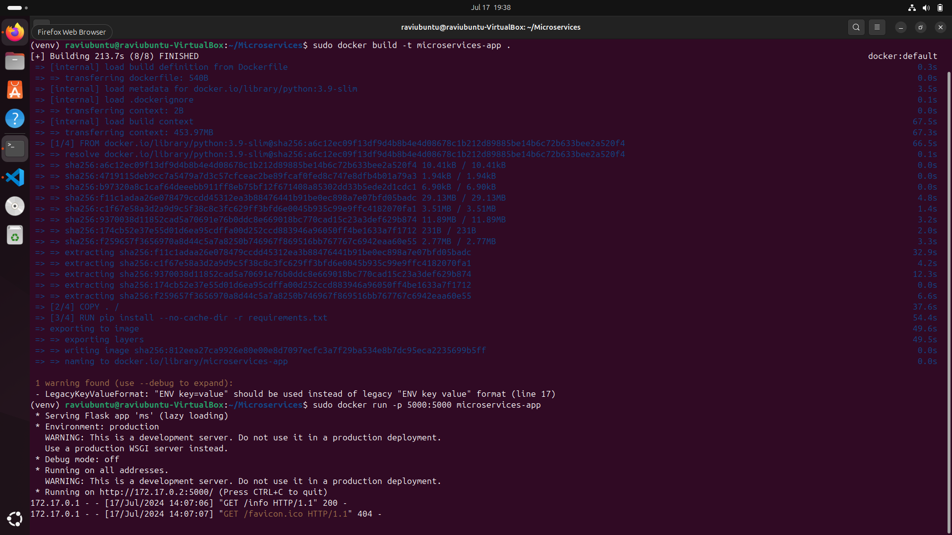

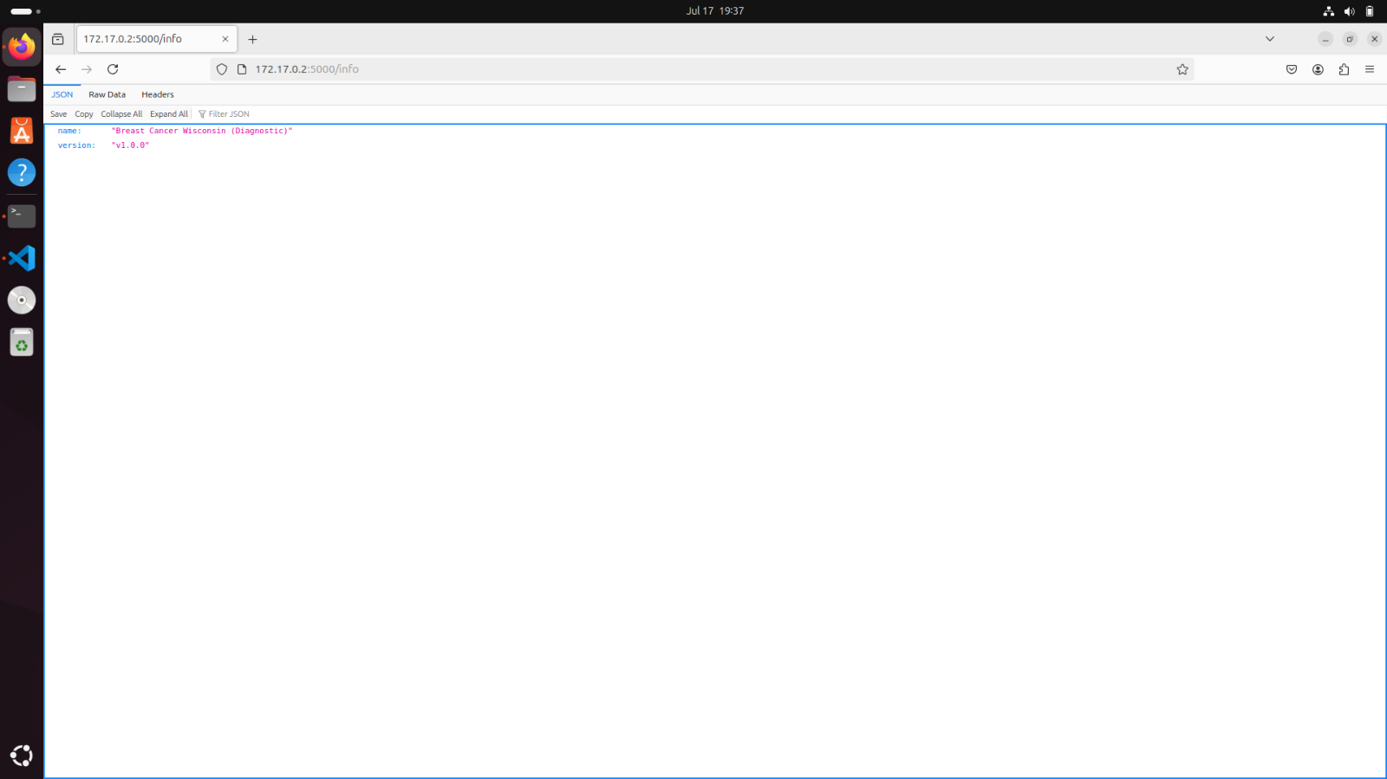

9. Test the application and make predictions using the example calls available in the folder

**/tests.** (5 marks)

10. Create a docker image containing everything needed to run the application.(10 marks)

11. Run the containerized application as a prediction service and test it locally by passing

some example calls and get the prediction. (10 marks)

One Malignant and One Benign

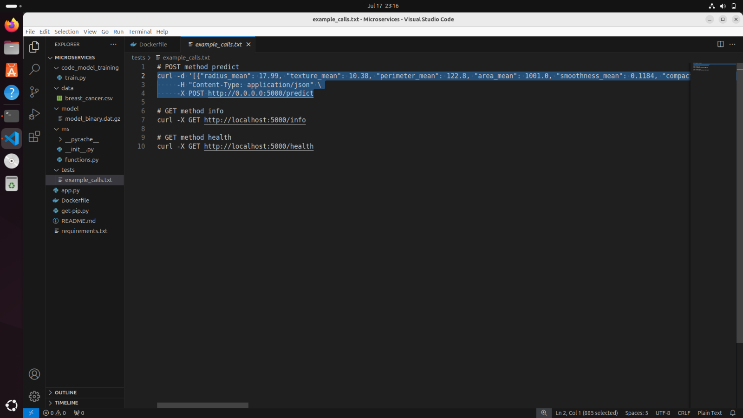

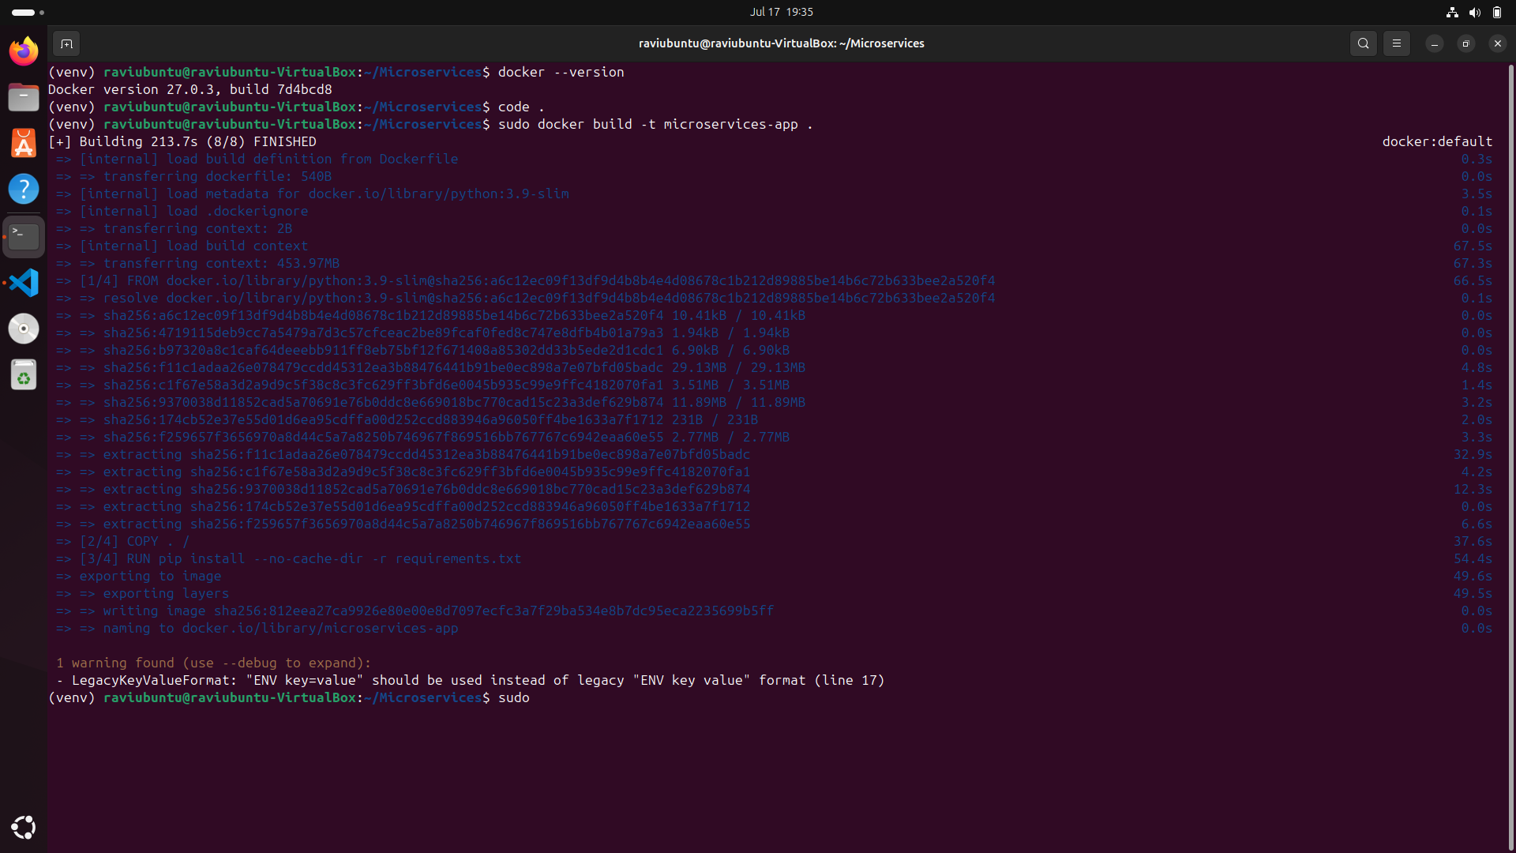

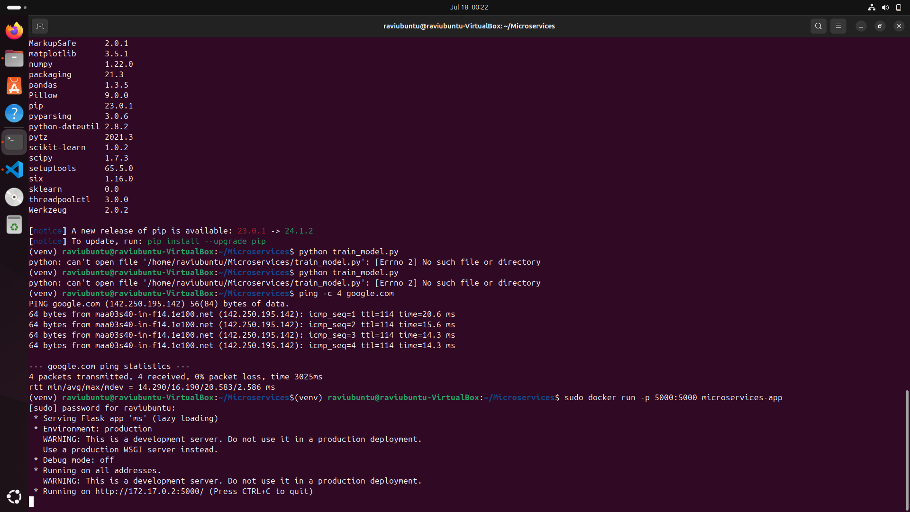

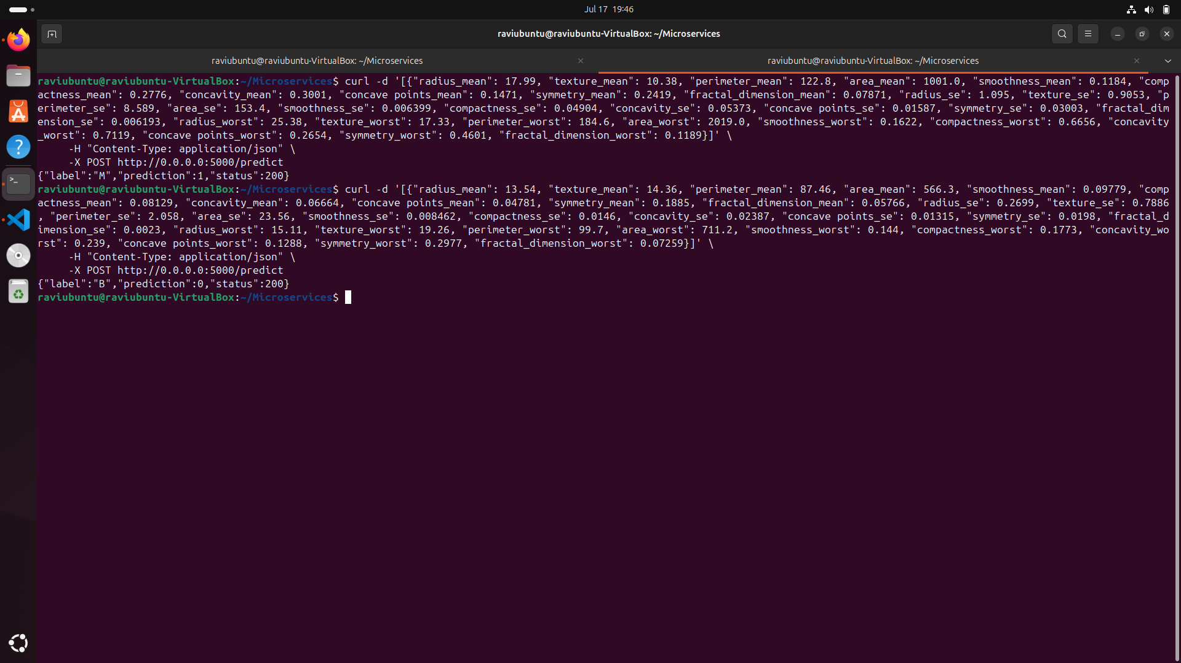

**Solution Submission Instructions :**

Create a git repository name it as {Ravishankar_W11_Graded Assignment },**make it public**

- Push your solution files to the repository. - DONE

- Submit the git URL link in the text entry box. –

<https://github.com/ARS876/-Ravishankar_W11_Graded-Assignment>